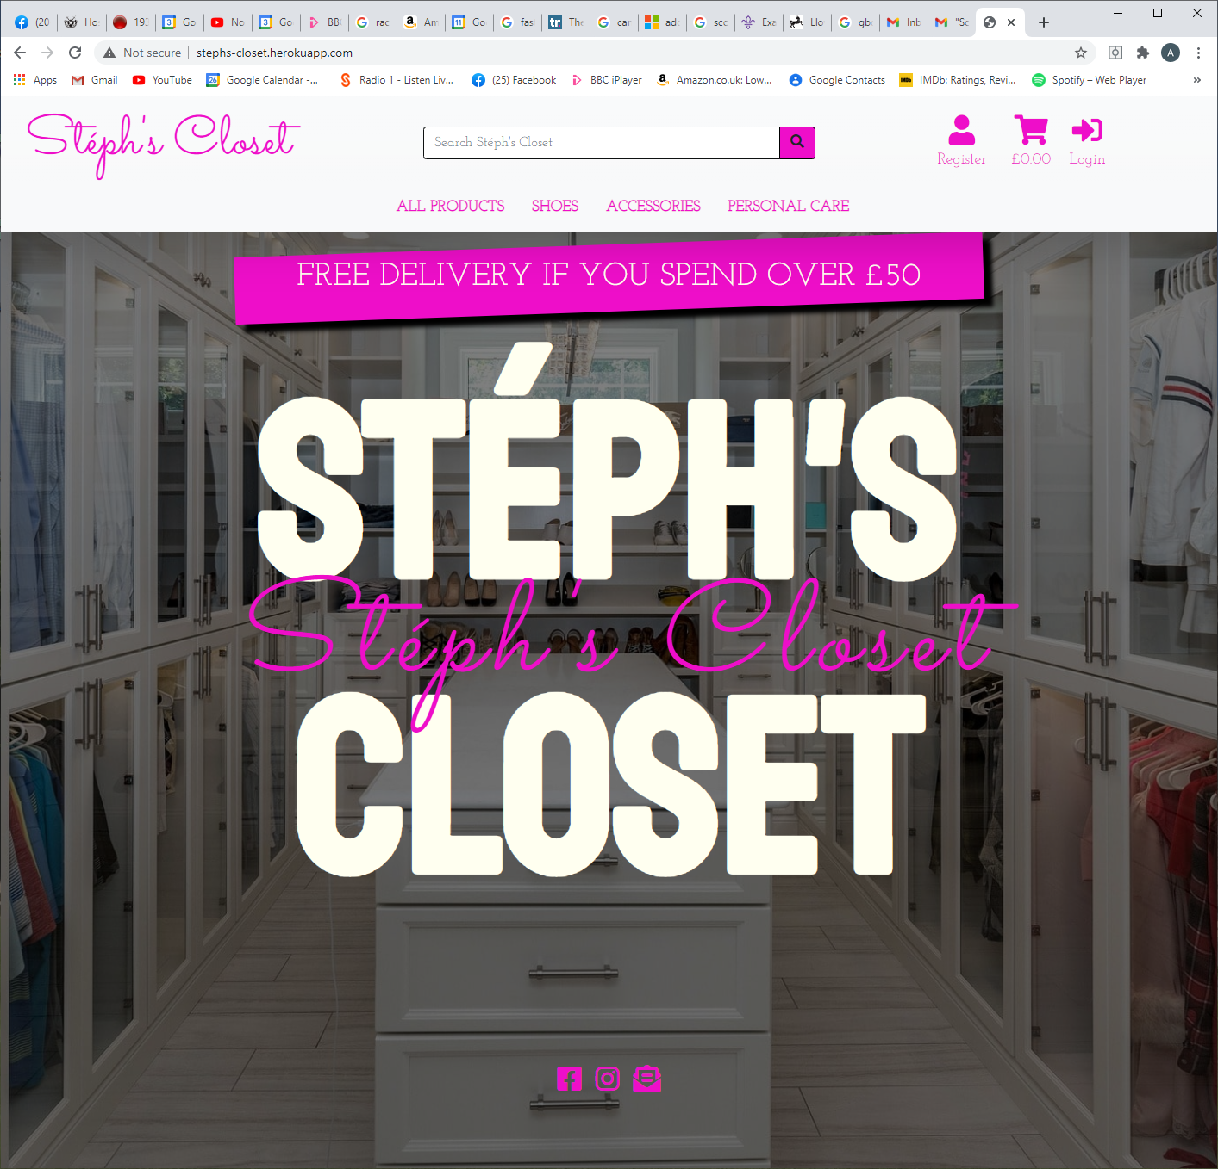

From a pc POV - the free delivery banner is slightly under the header of Stephs closet

Personally - I love the pink and the way that it ties in with the main picture (GOOD JOB on the font choice!! Looks like writing - backed up by the white bolded font. If I was to be REALLY nitpicky - the thingie above the E in Steph and the ‘ between the h and the s don’t match the lineup. (pink is low then high / white is high then low.

Are the three icons at the bottom intended to be directed anywhere (facebook/messenger contact) Instagram?/ print?

Clicked on login - lets see if I can retrieve my previous logon..

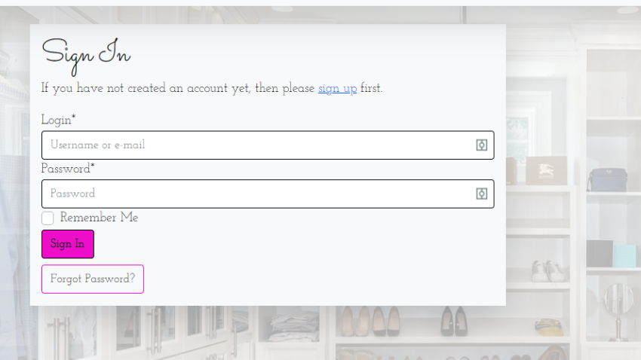

Loving the fact that the same style of writing is followed through for Sign In … as in the pink writing. Feels connected :D

Not sure if this this PC thing - or if you have got YOTI password manager (icon at far right of boxes) - anyhoo… ive ingored YOTI sign on an typed username/email & password & INGORED remember me (not my pc!) & then clicked on sign in.

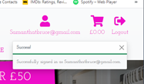 excellent!!! Clicked on the X to clear.. now lets go shopping!!

Scrolling through personal care - noticed four products pictures missing on page 1 (screenshots below)

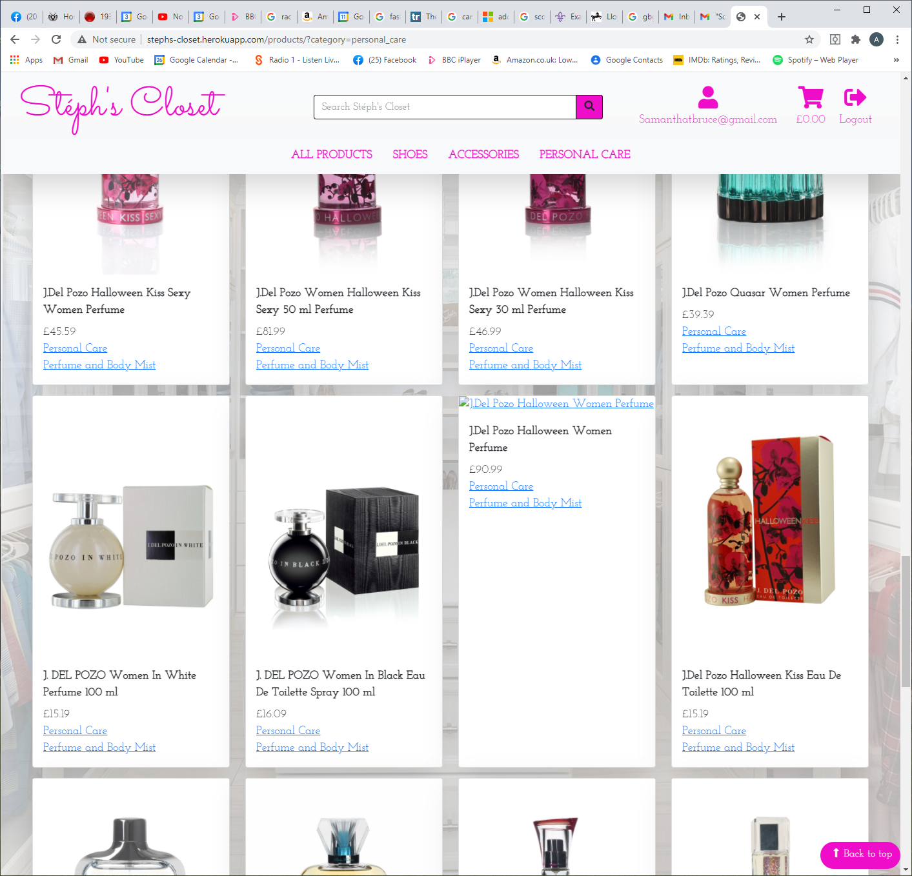

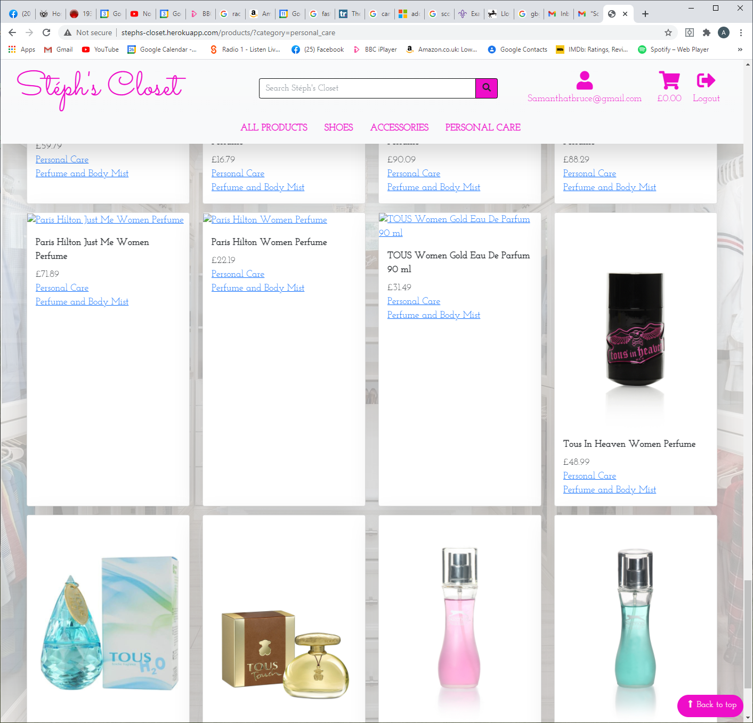

Page 2 - pictures also missing

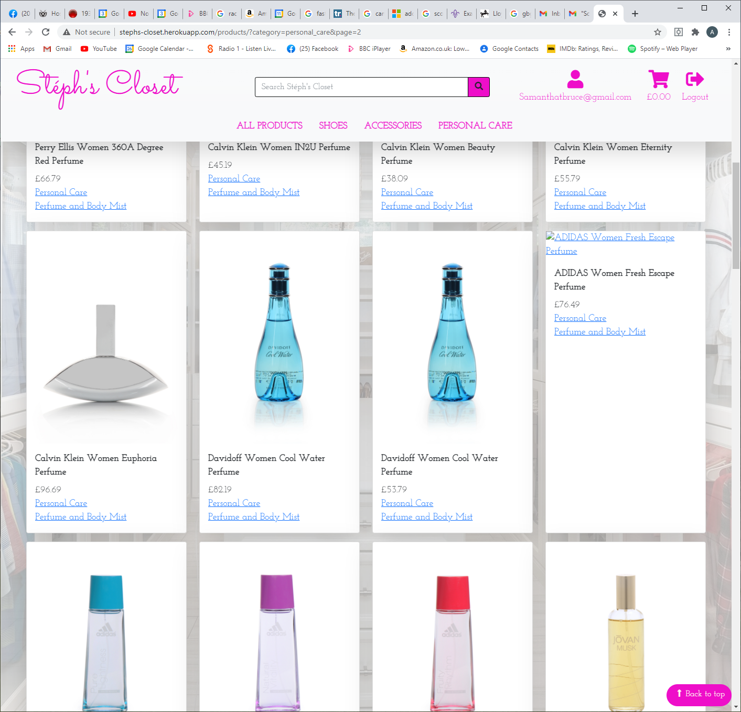

Page 5 - products missing

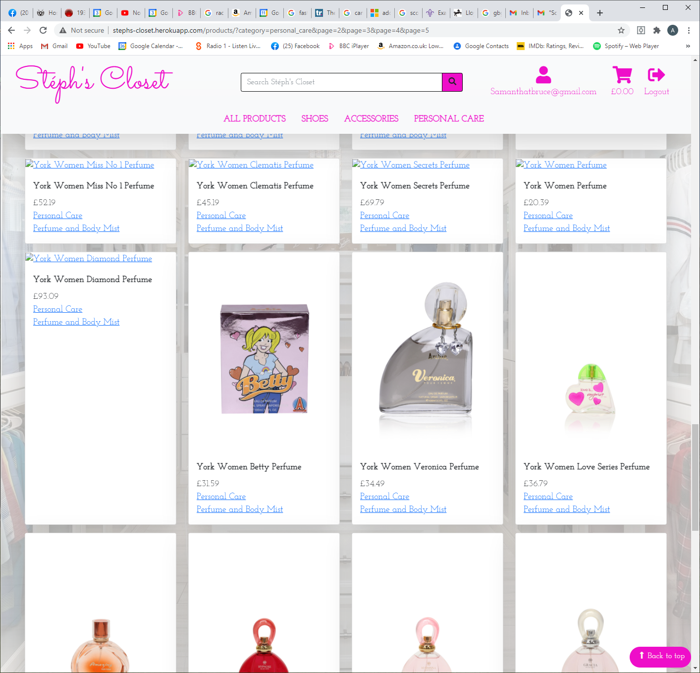

Page 7 - nail polish pictures differ.. most are without splash of colour - one is.. you need to be consistant 😊

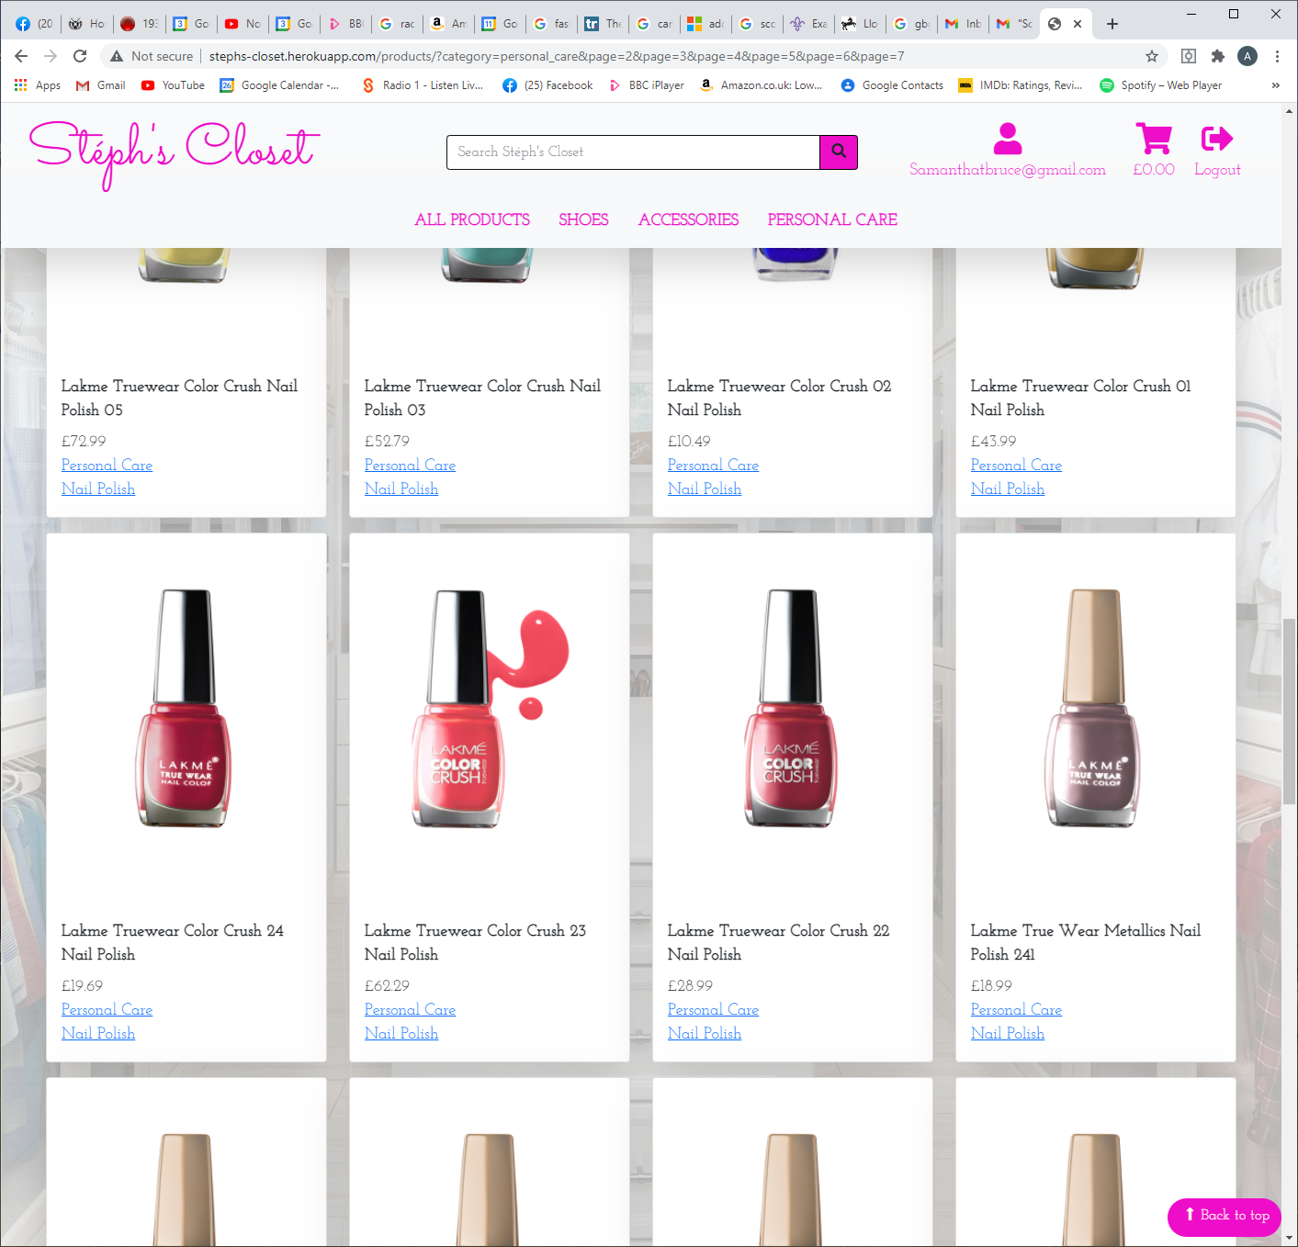

Page 8 - wording under pink square - hottie & nothing under the next one..

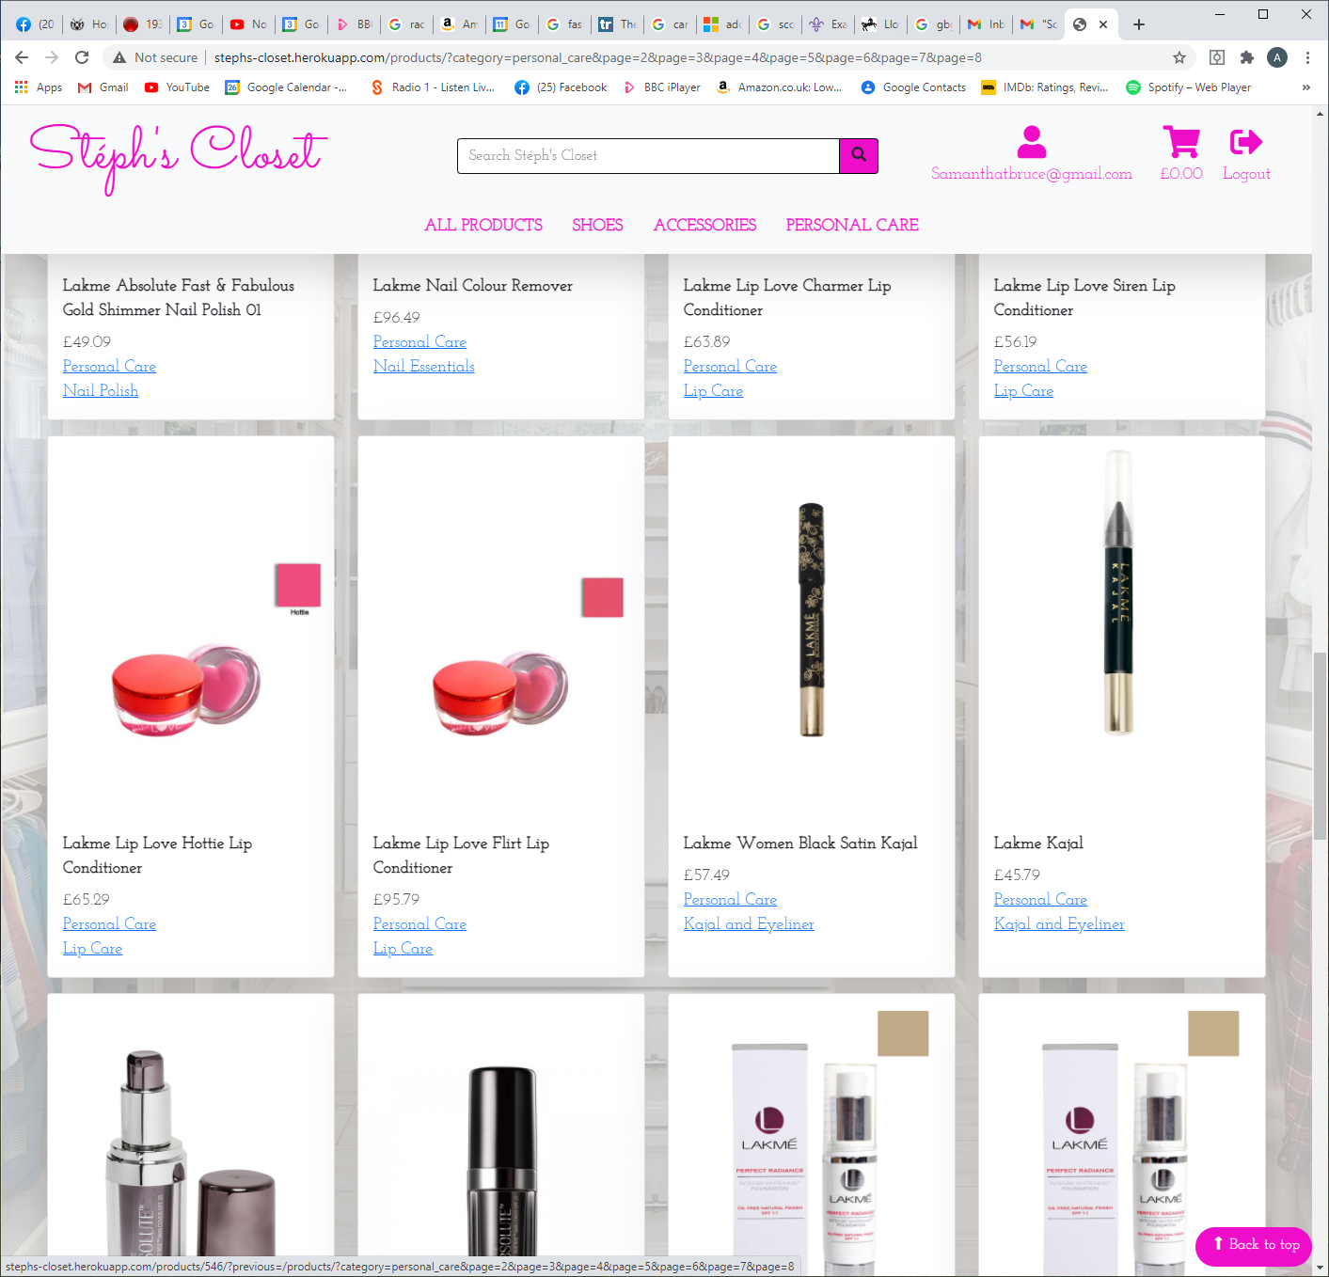

Page 9 - pictures differ for lip gloss - one has a stripe behind and stands straight up (powdery looking) the other looks more liquid with a blob and rests at a kookie angle. (prefer the blob personally as this shows it’s a liquid product rather than a powdery substance…)

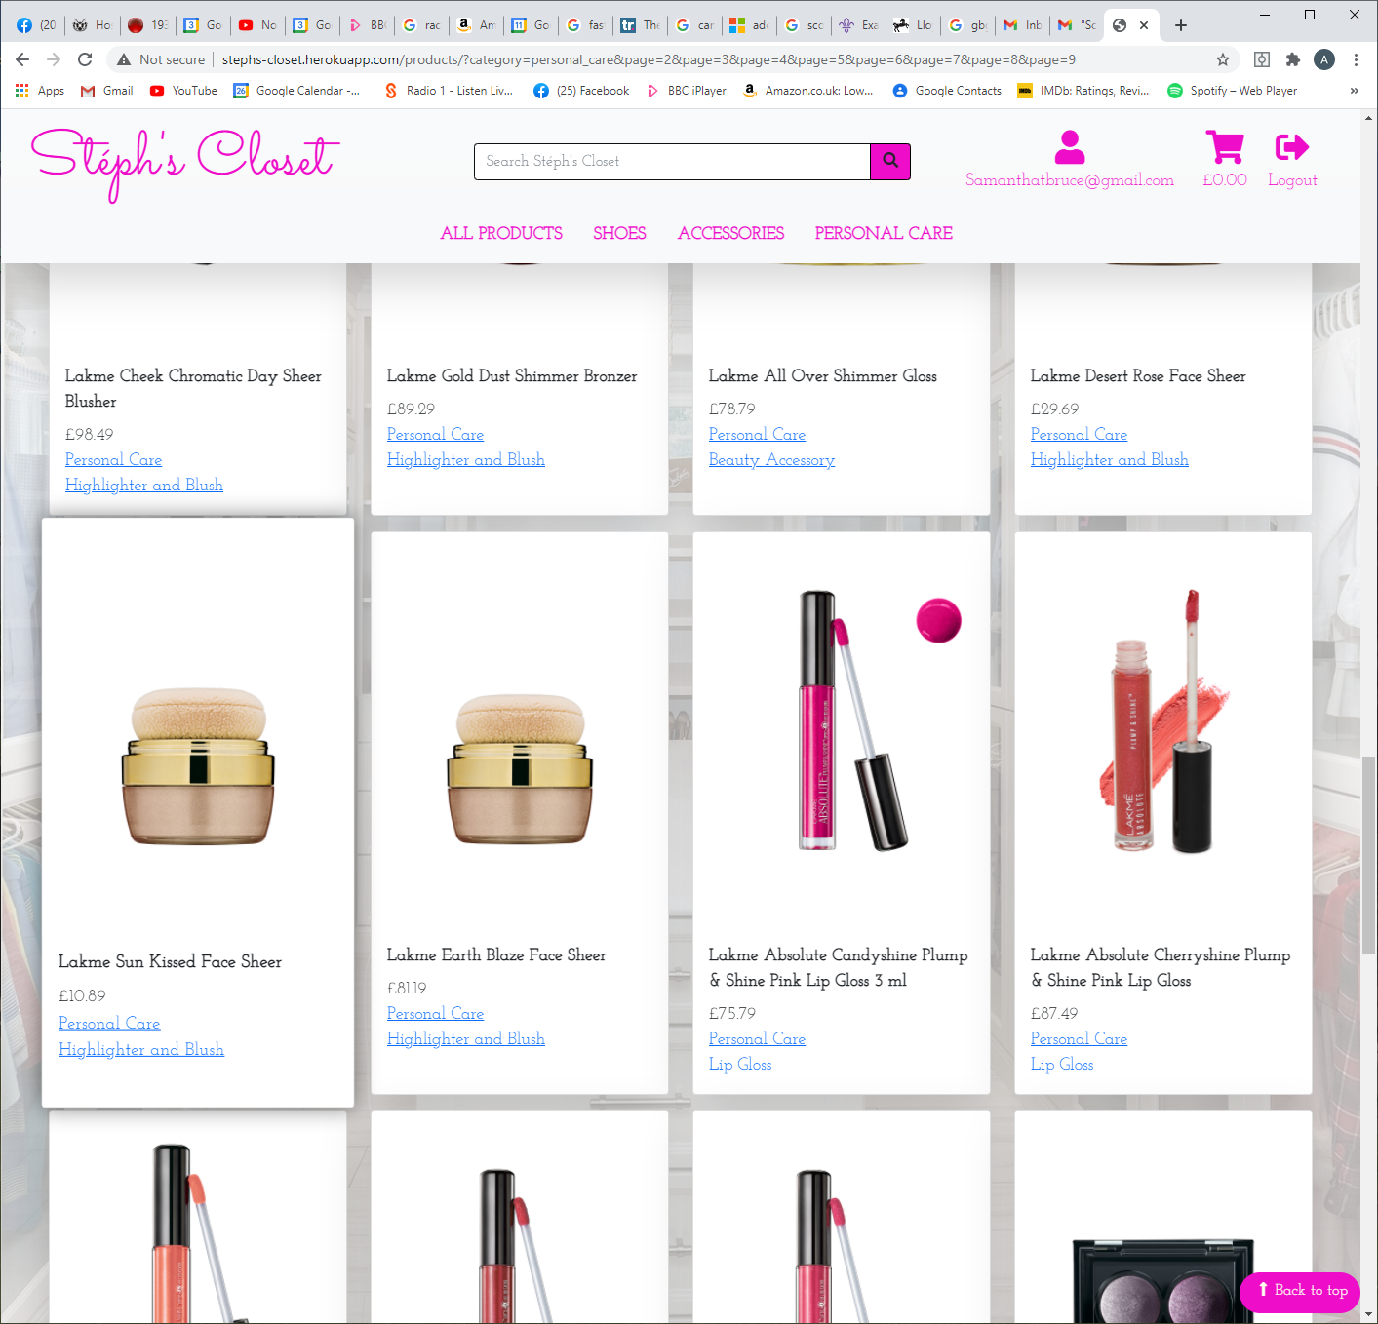

Page 10 - tunscan sun nail polish 314 stands out more so than the rest….. flagging for the same nit-picky reason ----consistency 😊

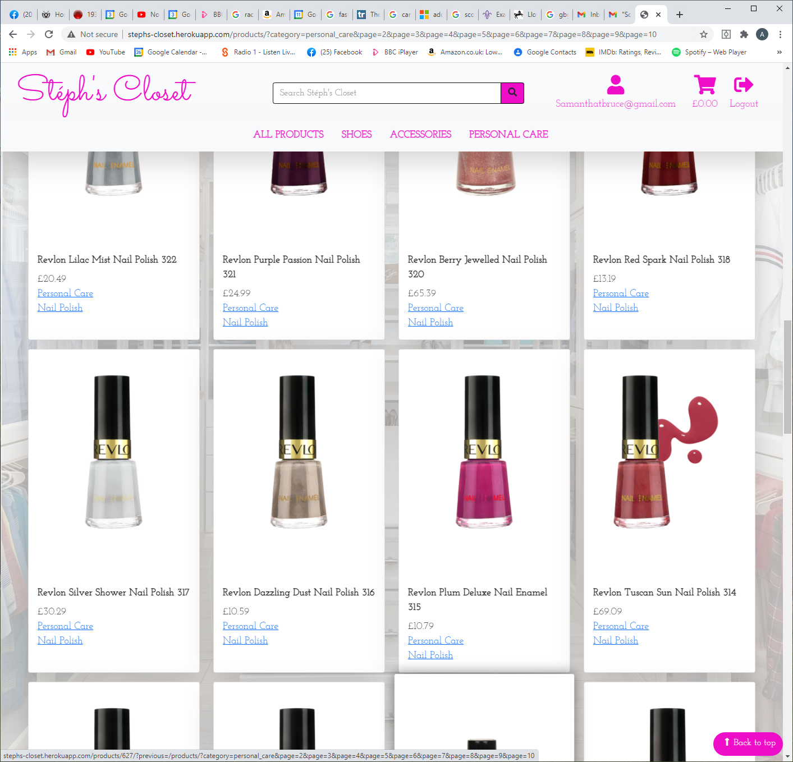

Same page - the Revlon colour burst aubergine is the only Revlon that doesn’t have a blob…… and the blobs are not in the same place? Intentional? Looks like an afterthought?

Page 11 - not all blobs are the same 😊

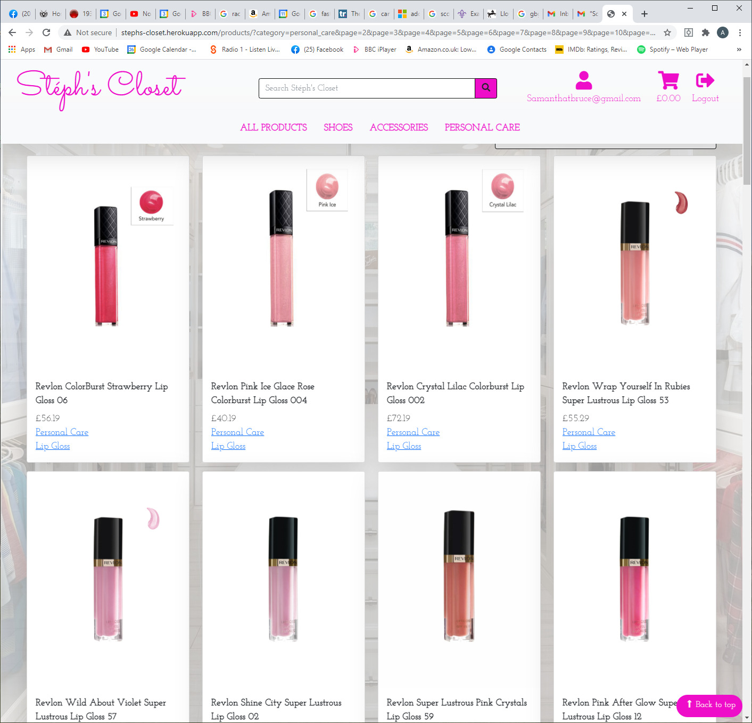

Do I get two for the price of one on this one?

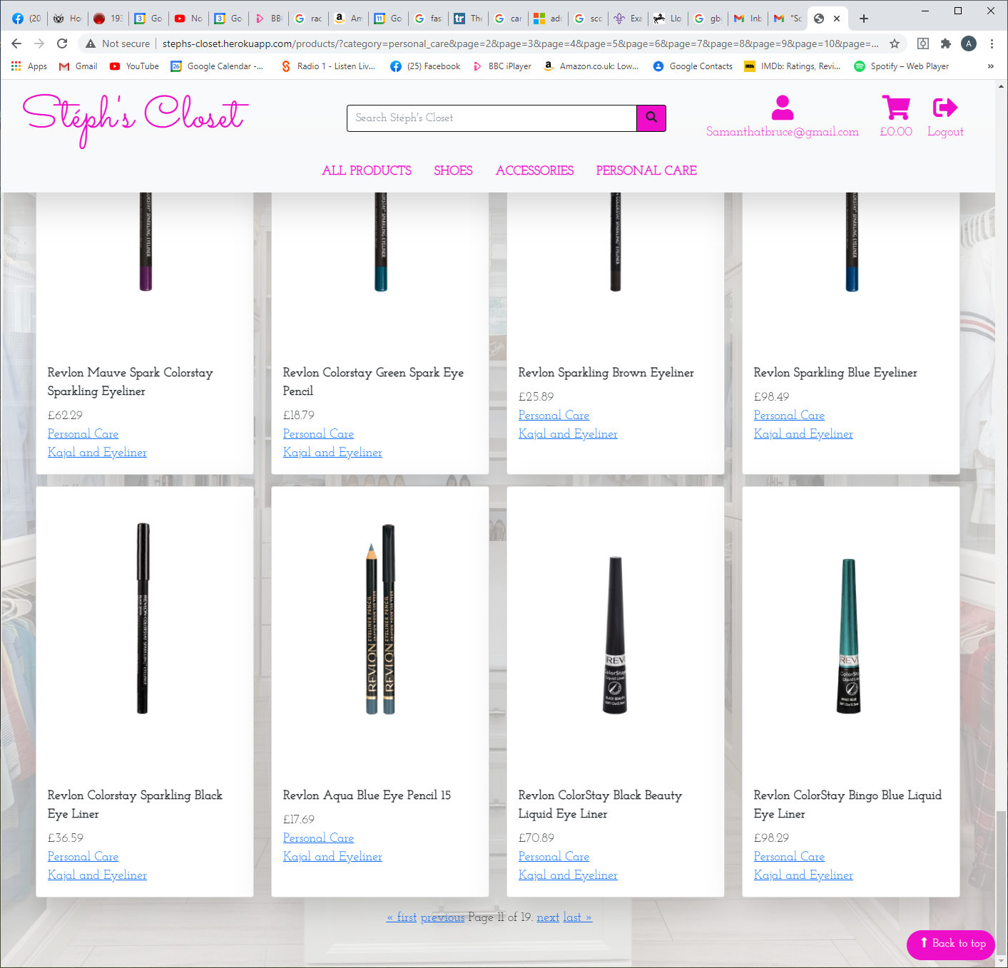

Page 12 -- revlon fabuline black eye liner ….. top on AND standing on its end? Its this two brushes?

Page 13 - missing product (screenshot below)

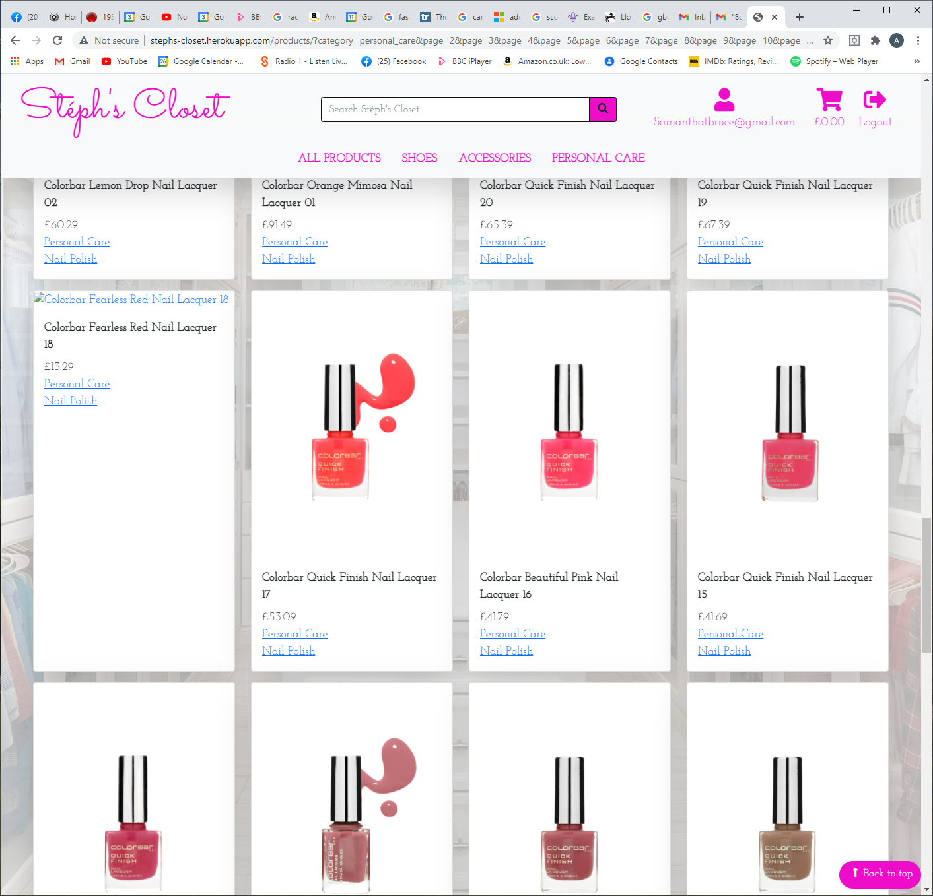

Page 15 - most of the pictures have square samples - some are labeled, some are missing altogether.

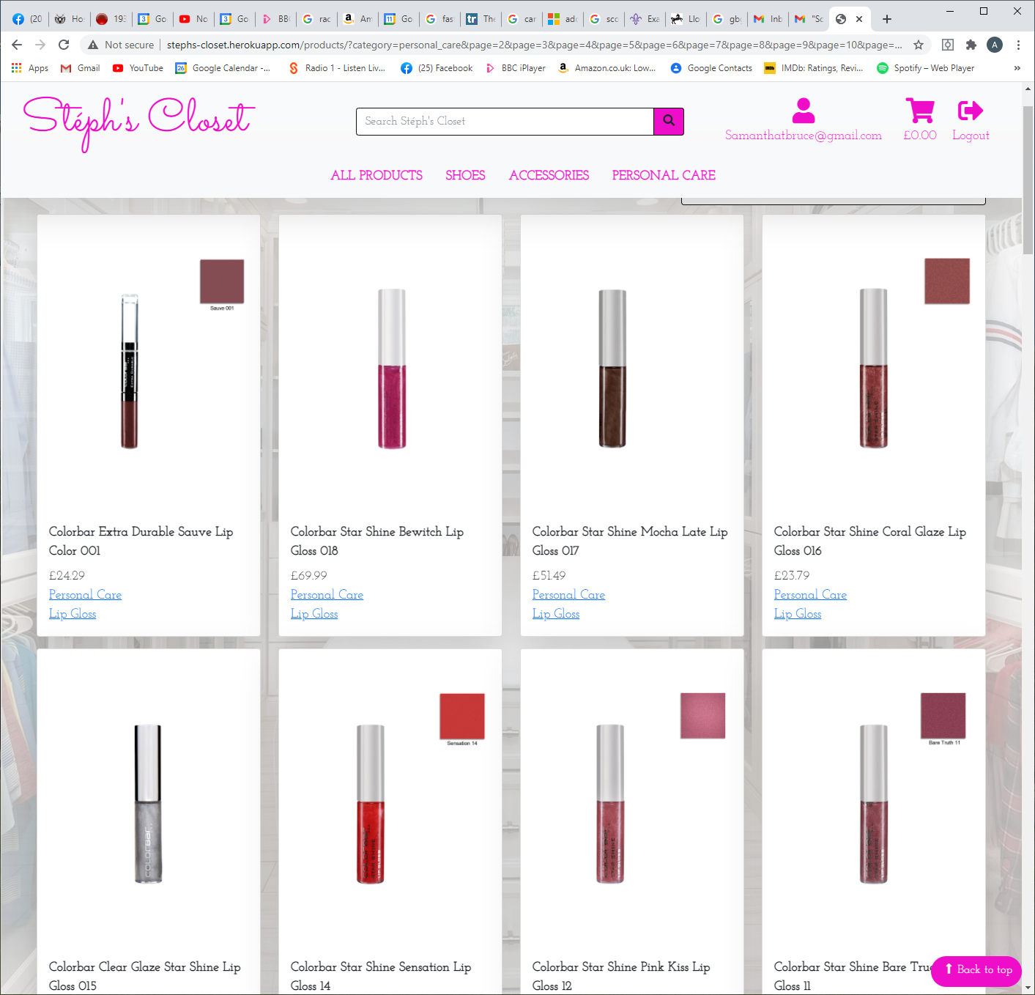

Page 16 - LOVE the squiggles behind the eye liners - gives the picture … personality :D 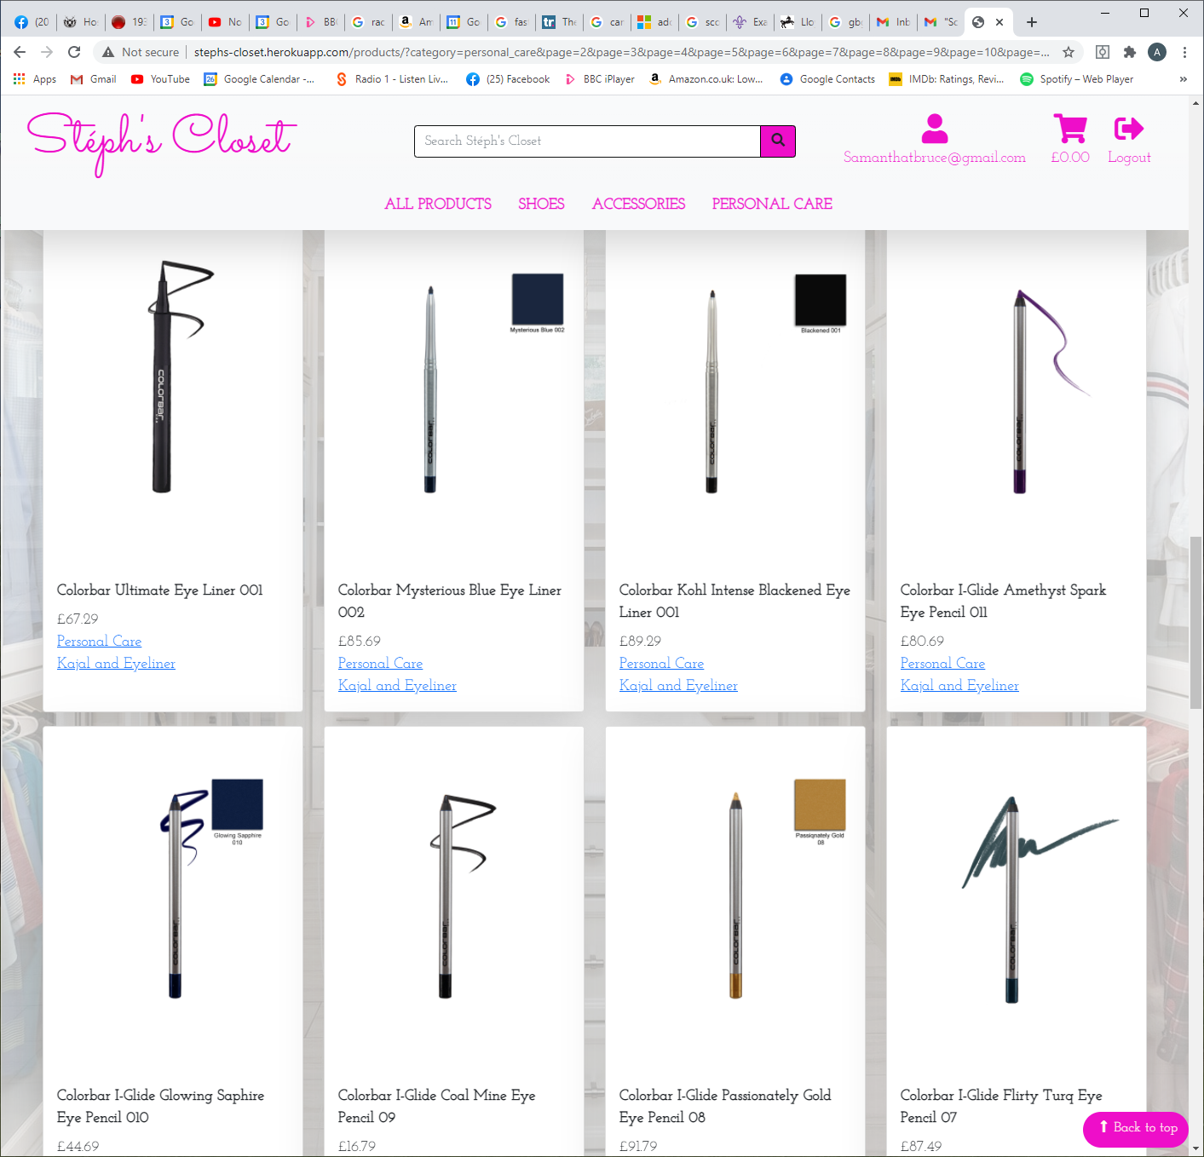

In personal care - there are no subheadings - but within the products themselves there are two.. personal care & nail polish / eye liner etc….

Accessories:

Product missing

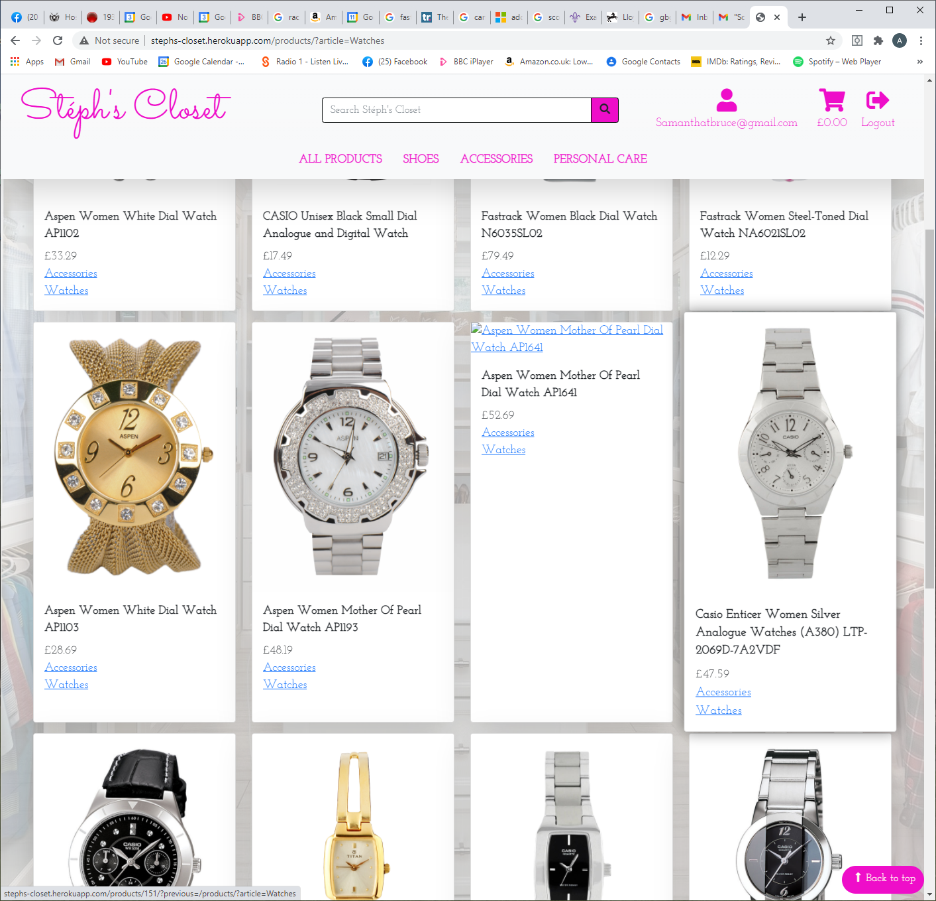

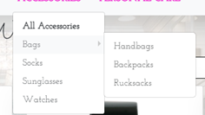

All links work okay and take to to the area needed. I’d suggest that the socks, sunglasses, watches, handbags, backpacks & rusksacks are slightly darker as you want to direct your shoppers to these areas… BAGS is a ‘folder’ which the mouse hovers over opens up the ‘subfolders’… OR made the arrow bolder so that its clearer to the shopper that there is more stuff to browse.

Sort by price/ name.. personal feeling… meh.. its too vague… its taking EVERYTHING on the website and putting it into price order. Could this be sorted within a specific product range?

Maybe include a sort by size option on shoes - so shopper can narrow down choice further? Say, sort by shoes, heels, size 6 (for example)

Ordered Cobblerz women gold-toned sandals - x 1

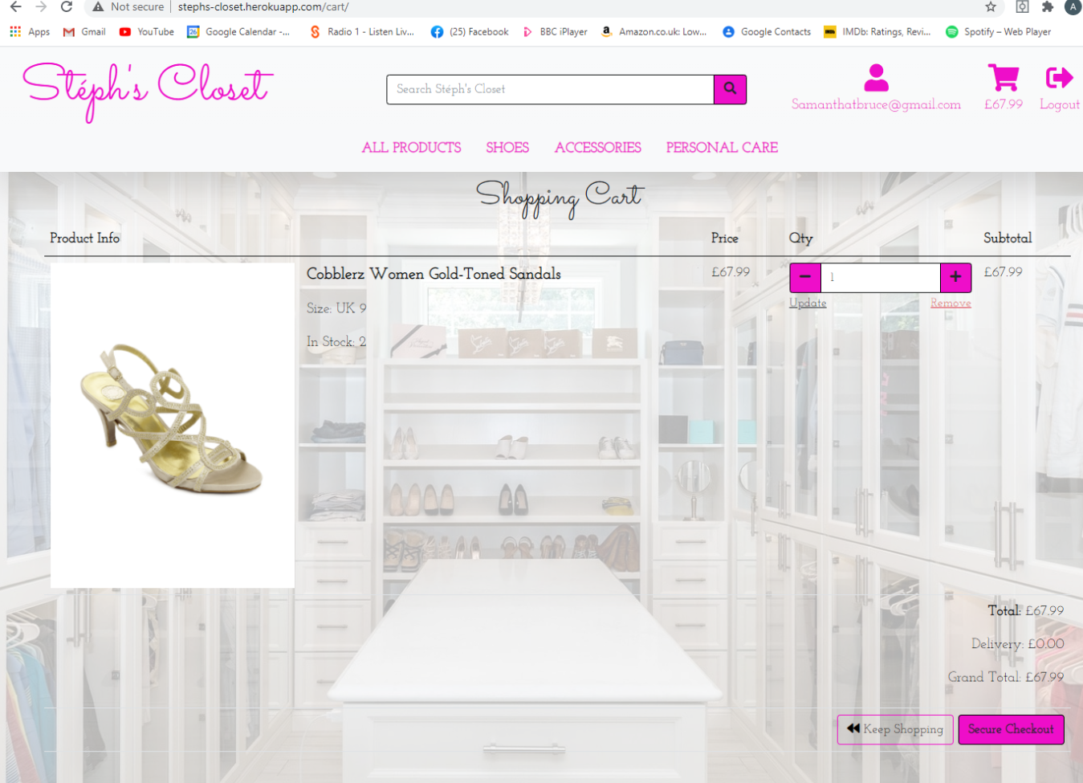

Then ordered 3 more as noticed 2 in stock.. error flashed up.

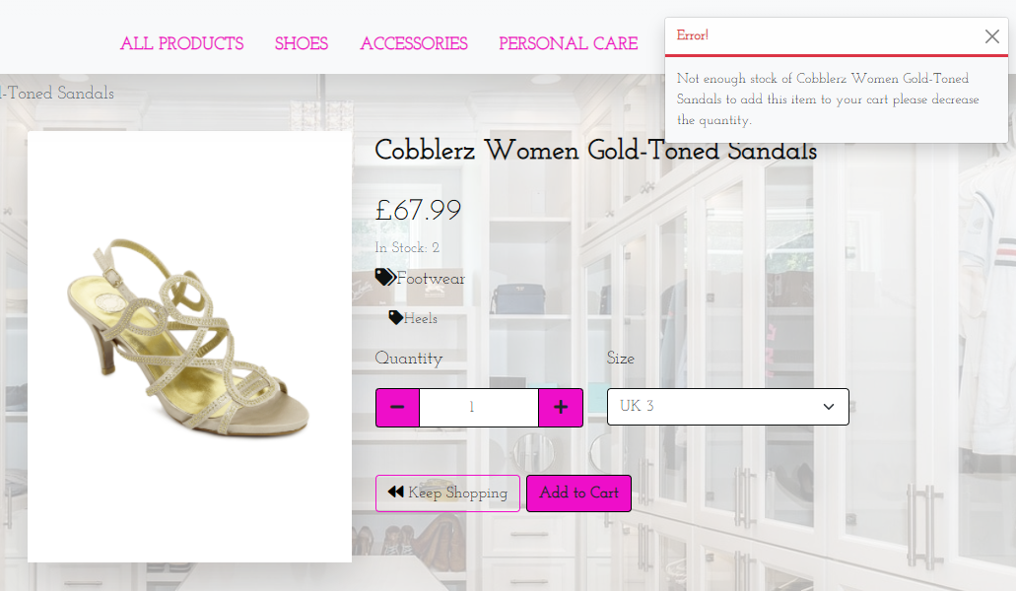lets me add in as many shoes as I like which .. .as long as its multilples of 2……..

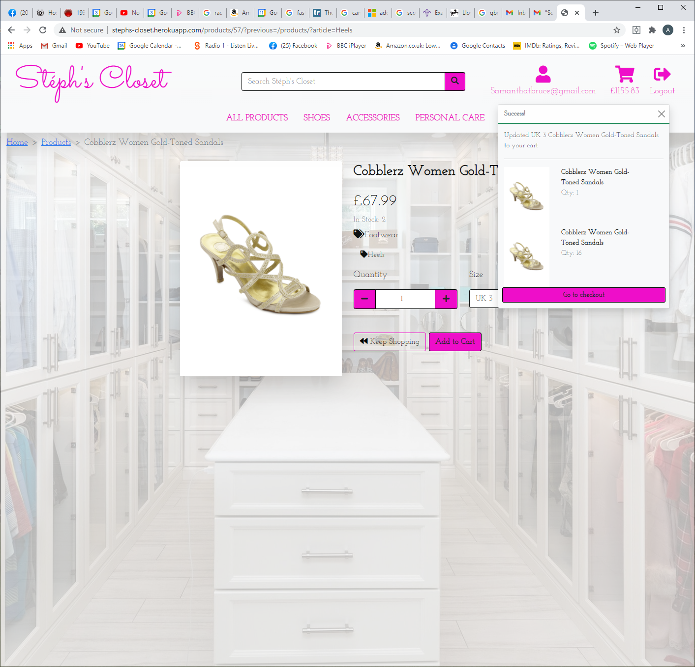

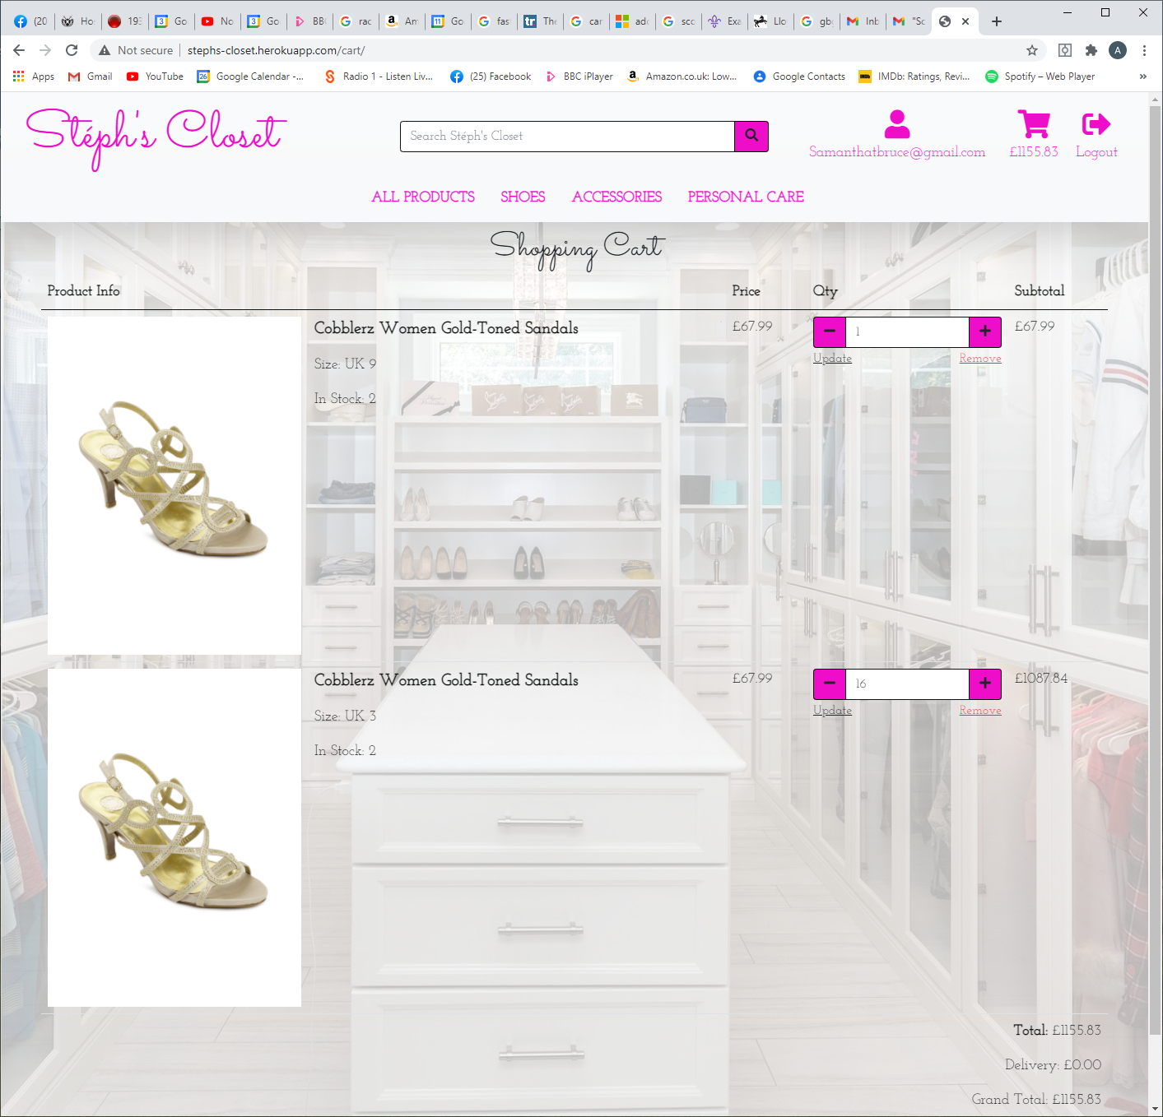

I agree with the comment that Dad made - the writing that im seeing the most is the name of shoe…. The important bit .. how much I’m spending could be made clearer…

Plus you are now gonna charge me for shoes that you don’t have in stock!!

Error when paying out… ive not amended the postal code.. JE2 3AB is correct :D

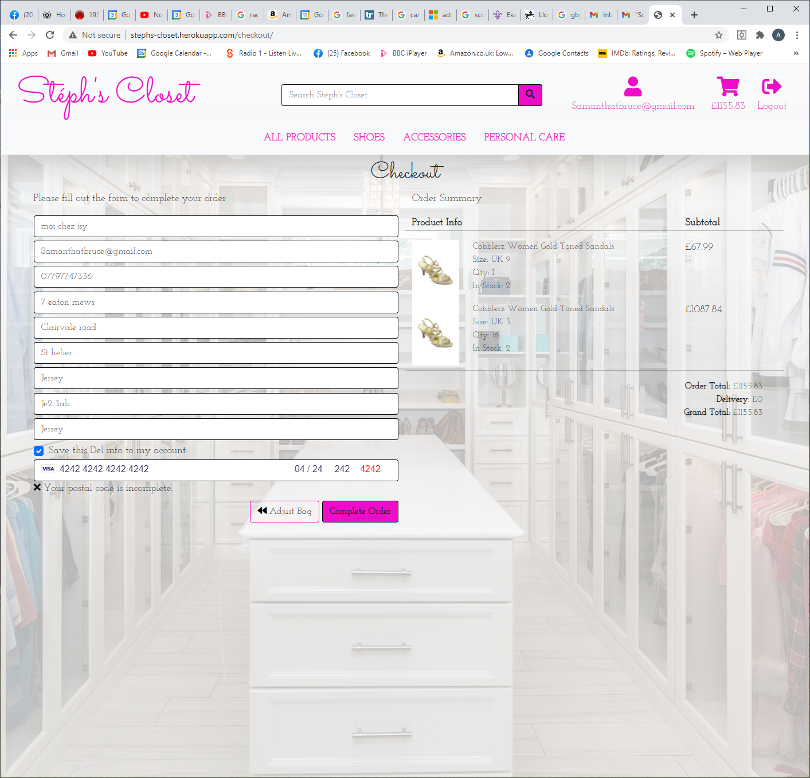

Retyped

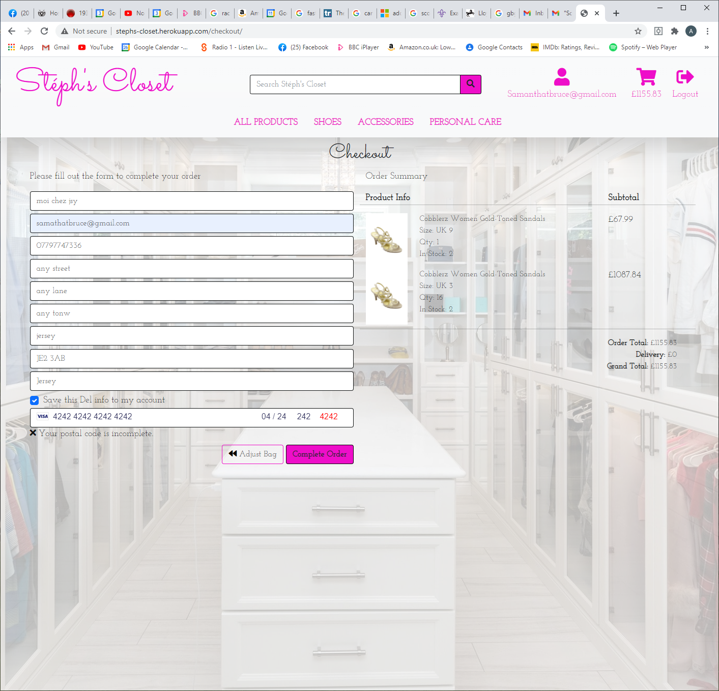

Order can’t go through..